Jeremiah Hsieh

ICSI 500

Project 2

**System documentation**

i.   
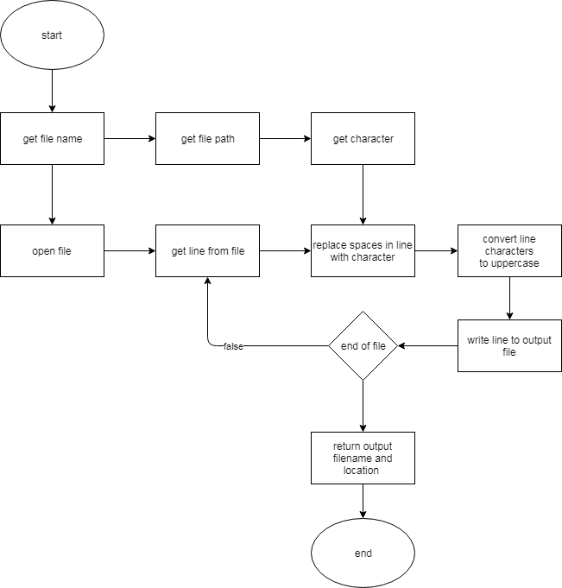

ii.

-the reader thread reads file line by line and passes line to queue for character to read

-the character thread gets line from reader queue and replaces spaces with specified character with the result pushed to another queue

-the toUpper thread gets line from character queue and converts it to all uppercase with the result pushed to the final queue

-the writer thread gets line from toUpper queue and writes it to output file

-the main thread executes the previous threads after getting data from the client and then returning values to client

-currentDir gets the current directory location of the server

iii.

I used threads to run the different functions that modify the file contents and global queues to transfer data between the threads. I used the client server program from lab 9 as the basis for sending commands from client to server and the results from server to client.

**Test Documentation**

i.

I tested the program by sending the standard values (ie. >file.txt g) which returned the expected results. I also have some minor error checking for commands (ie. >test) which simply checks the number of arguments to be equal to 2 or not. I don’t have checks for whether the 2nd parameter is a char or not. I did check for whether opening the file is valid before proceeding with thread running. There are no unique error messages for commands, just that the command is invalid. Additionally, as a carryover from lab 9, the client and server will display whether sockets are valid and whether a connection is established. Unfortunately, I didn’t have another computer to test if the program works over the internet connection but as far as I can tell it should be able to.

ii.

Server will display waiting and conversion completions while client will get returned result values. Client will send command (ex. file.txt h) and run the process on the file. The server will return the file name, path, and contents to client.

**User Documentation**

i.

Source files are included with document.

ii.

Much like lab 9, simply run the ./server 54454, then ./client 127.0.0.1 54454, then run “exit” to close server or “file.txt c” to run server program on file.txt and run character function using char c.

iii.

The only running parameters are the server sockets and the client server address and socket.